Sprint 3: BackEnd Documentation

In this sprint we have achieved the following pertaining to backend:

1)Luggage Delivery Booking:A signed in user can now place an order to transport his/her luggage from the source to destination.They can now be added to the database.

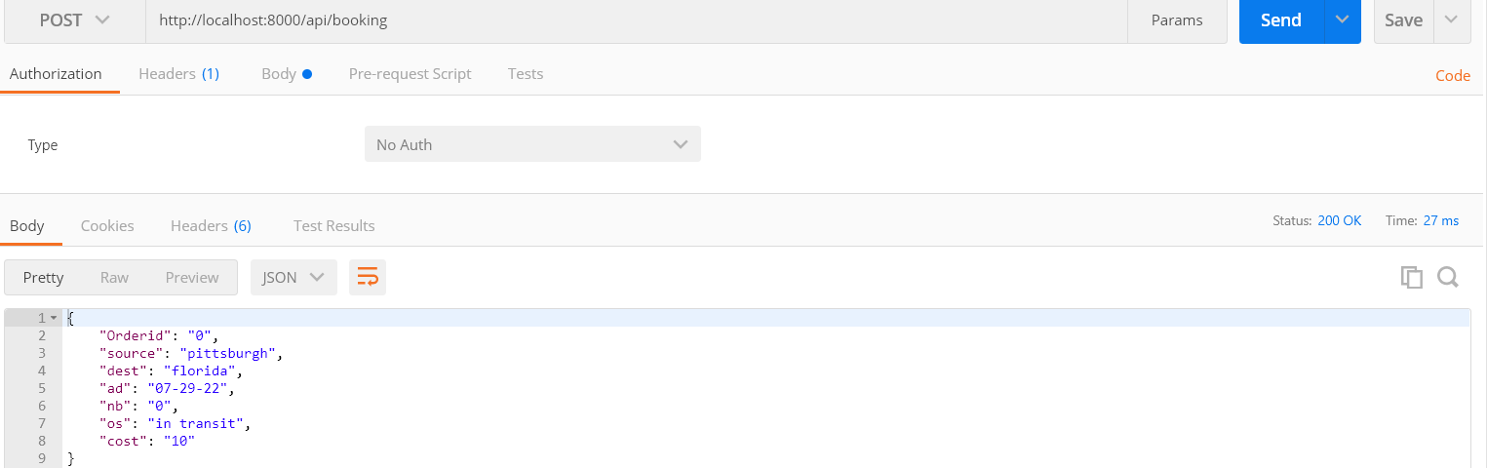

Api:http://localhost:8000/api/booking

Method:Post

Status: 200->OK

If any other incompatible data is sent:

404->Error

401->Unauthorized

429->Too many requests

2)All baggage orders placed and their status can now be retrieved from the database.

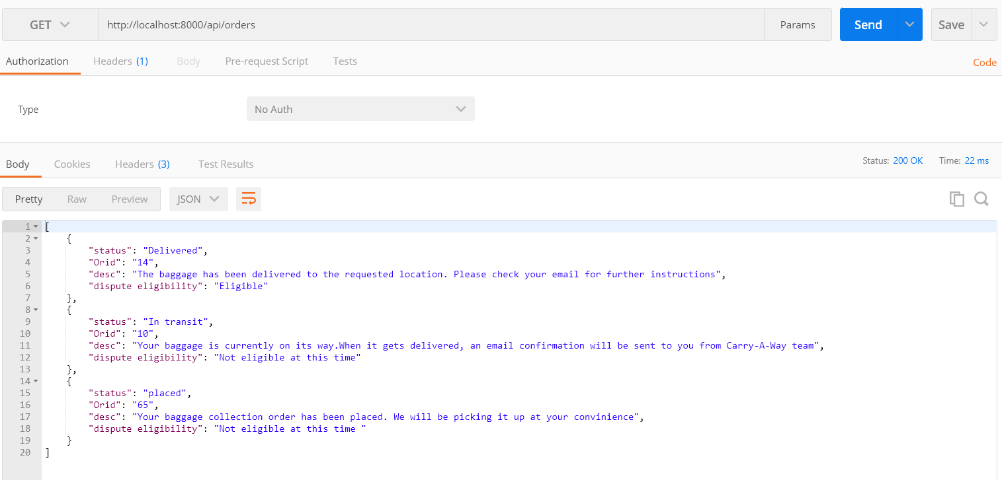

Api:http://localhost:8000/api/orders

Method:Get

Status: 200->OK

If any other incompatible data is sent:

404->Error

401->Unauthorized

429->Too many requests

3) All baggage orders placed and their status can now be retrieved from the database using Orid(order id)

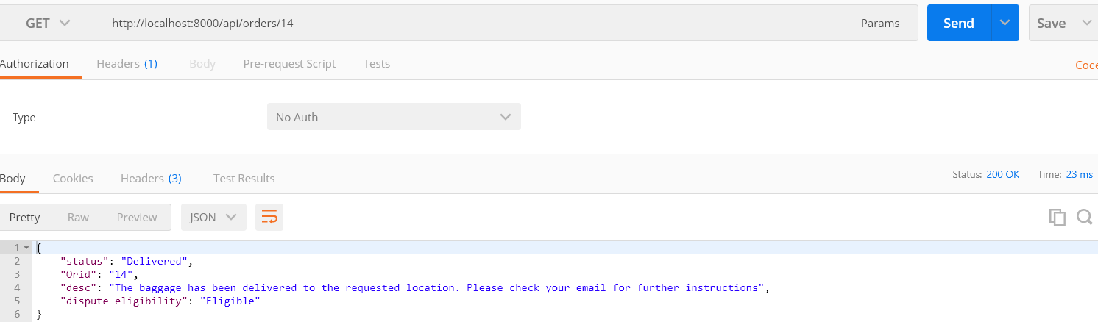

Api:http://localhost:8000/api/orders/id

Method:Get

Status: 200->OK

If any other incompatible data is sent:

404->Error

401->Unauthorized

429->Too many requests

4)Baggage status can be updated by carry a way team from time to time.

a)Before the transit status got updated

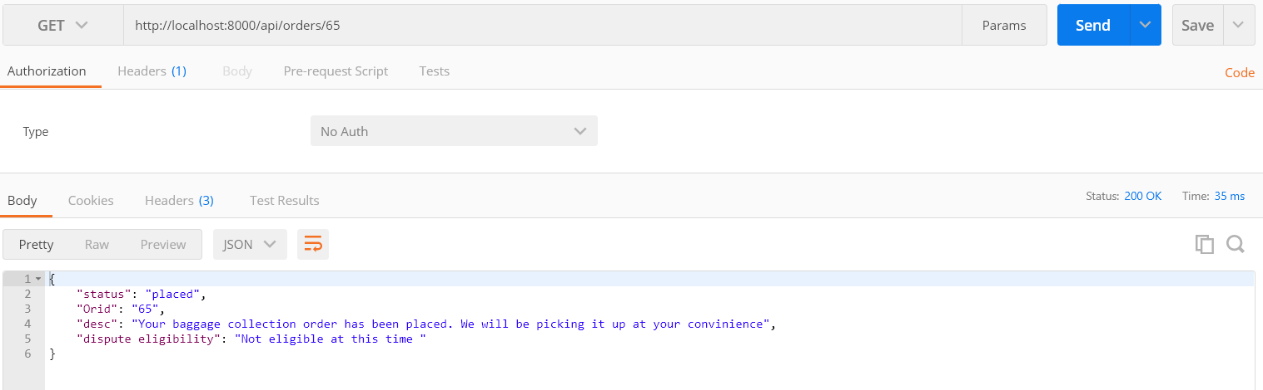

b)After the transit status got updated

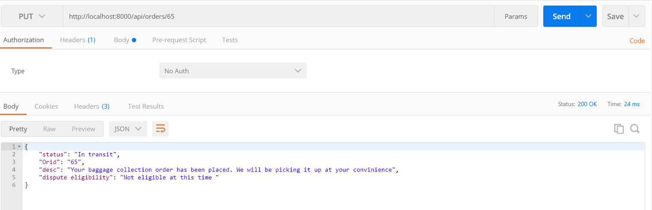

Api:http://localhost:8000/api/orders/id

Method:Put

Status: 200->OK

If any other incompatible data is sent:

404->Error

401->Unauthorized

429->Too many requests

5)Customers can delete their baggage transport order if they wish

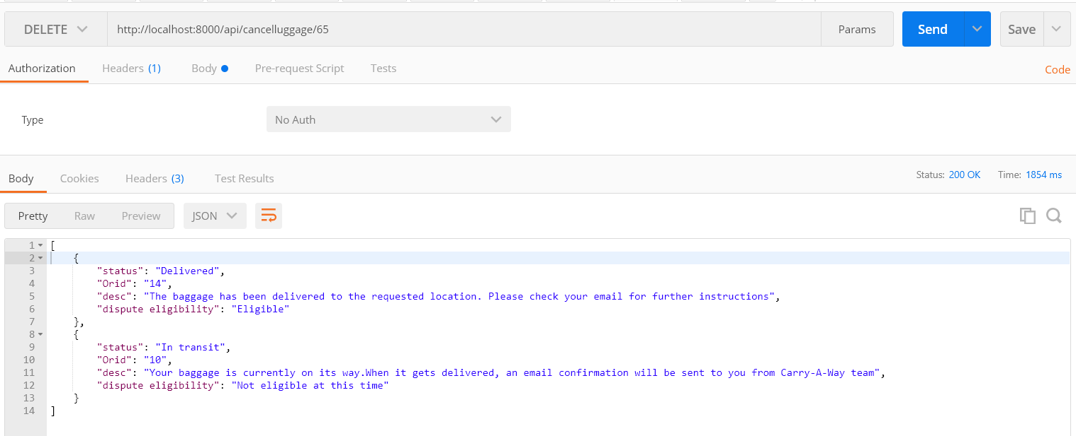

Api:http://localhost:8000/api/cancelluggage/id

Method:Delete

Status: 200->OK

If any other incompatible data is sent:

404->Error

401->Unauthorized

6)Following unit tests have also been performed

a)Test case has been written to test if all orders placed can be retrieved

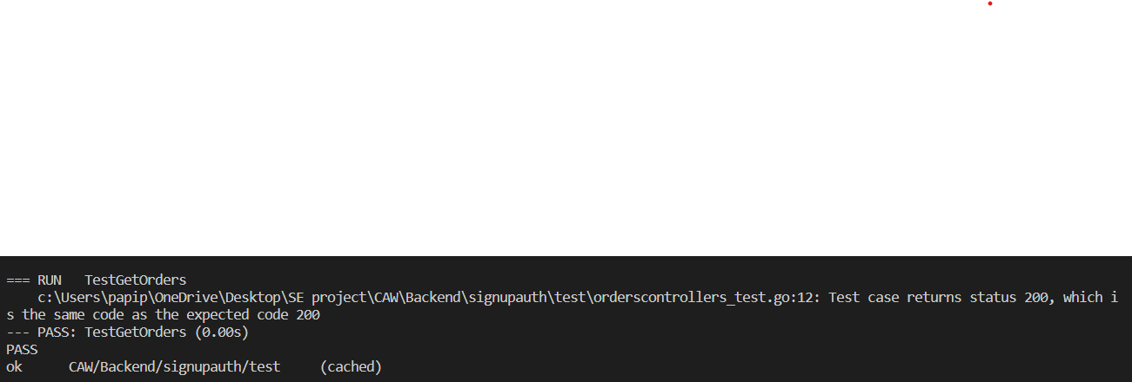

b) Test case has been written to test if all orders placed can be retrieved by id

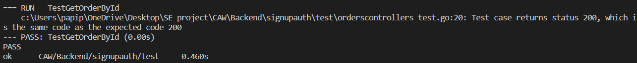

c)Test case has been written to check if the transit status can be updated

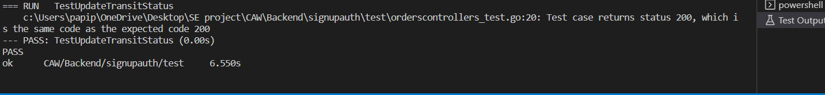

d)Test case has been written to check if luggage order can be cancelled

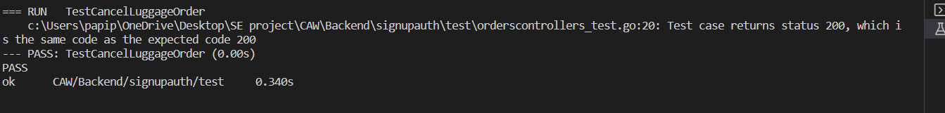

e)Test case is written to check if password is hashed

